The Legend Lives On

American Great Lakes freighter the S.S. Edmund Fitzgerald was a household name in Michigan for decades due to its tragic history. Once known for its power and record breaking of the largest loads carried across the Great Lakes, the Edmund Fitzgerald is now known nationally from an ill-fated journey across Lake Superior on the 9th of November in 1975.
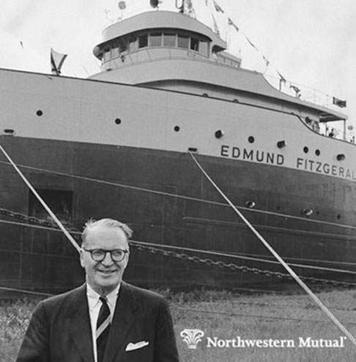
February 1st of 1957 can be considered the birthdate of the mighty ship. A contract was signed by the Great Lakes Engineering Works (GLEW) and Northwestern Mutual Life Insurance Company. The contract specified that GLEW would not only design, but oversee the building of the largest ship to sail on the Great Lakes at the time. The ship was to be built to facilitate the transfer of taconite pellets, an iron ore, from Michigan mines to iron-making blast furnaces in Detroit and Toledo. In 1958, Northwestern Mutual announced that they would name the ship after their chairman of their board, Mr. Edmund Fitzgerald. Edmund Fitzgerald’s father served as president of Milwaukee Drydock Company and his grandfather was a ship captain. The name of the massive ship was an honor to Edmund, who had familial ties to maritime affairs. The name was fitting as Fitzgerald was actively involved in the Port of Milwaukee and had helped establish the Wisconsin Marine Historical Society. His son, Edmund B. Fitzgerald told a reporter that “the ship’s launch was the happiest day of his father’s life.” On June 8th 1958, Fitzgerald’s wife Elizabeth christened the boat and people were stunned by the massive size of the freighter. Measuring in at a length of 729 feet and a weight of 13,632 tons, when empty, it was recognized as the largest ship on the Great Lakes. It’s power came from Westinghouse steam turbine engines which generated 7,500 shaft horsepower with steam from a pair of coal-fired water tube boilers. Testing of the ship began in September of the same year during sea trials. After these trials were passed, the S.S. Edmund Fitzgerald would be allowed to officially begin its service of carrying cargo across the Great Lakes. On September 24th of 1958, The “Fitz” took her first voyage through the Soo Locks under the leadership of Captain Bert Lambert.
The ship was a record-breaking machine. After breaking a cargo weight record, she would set a higher standard and break her previous record. The ship’s record for a single trip was 27,402 long tons, set in 1969. At the time, this was an impressive feat and improved the ability to export taconite. The ship was hailed by the public and commonly referred to as “Pride of the American Side”, “Mighty Fitz”, “Titanic of the Great Lakes”, and the “Toledo Express.” The taconite was mined from Minnesota’s Iron Range near Duluth, and shipped to Detroit and Toledo iron works. A round trip to Detroit, Michigan and back typically took around five days, and the ship averaged around 45-47 trips per season. The route the ship usually took was between Superior, Wisconsin and Toledo, Ohio. By the night of it’s sinking, the ship had achieved an estimated 748 round trips on the Great Lakes. This would calculate to over a million miles and “a distance roughly equivalent to 44 trips around the world” (MacInnis 1998). With a maximum speed of 16 mph, the Fitz proved it was an impressive vessel. The records were set under the command of Captain Peter Pulcer. People from all over Michigan visited the Soo Locks hoping to catch the S.S. Edmund Fitzgerald passing through. While passing through the locks, Captain Pulcer would blast music through the ship’s intercom system and used a bullhorn to entertain the on-lookers with facts about the ship (Thompson 1994). Oakland County resident Neil (last name omitted for privacy) remembers visiting the Soo Locks as a young child during the late 60s and being in awe at the massive size of the ship and it’s notorious red and white paint job. By 1964, it had become the first ship to carry more than 1 million tons of iron ore through the Soo Locks in Michigan. During its heyday, the S.S. Edmund Fitzgerald received positive publicity, which eventually began to dwindle as a new decade began.
The ship’s problems started in 1969 when she hit the ground near the Soo Locks, causing internal and external damage. On April 30, 1970, she collided with another ship, the S.S. Hochelaga, causing further damage for a second time in less than 8 months. The Fitz lost her engine and was quickly rebuilt. On September 4th of the same year, the ship got further damaged after hitting a wall at the Soo Locks. In under 12 months, the ship was subjected to significant damage three times (ssedmundfitzgerald.org). Following these incidents, it was decided during winter maintenance In Duluth that the ship would be switched from being powered by coal to oil. The boilers were converted to be fully automated. Nonetheless, the S.S. Edmund Fitzgerald struck walls in the Soo Locks again in 1973 and 1974. In an accident in 1974, she lost her original bow anchor in the Detroit River, about one mile west of Belle Isle (Bishop 2000). These incidents were considered typical and not too serious. The ship was designed and built to last for more than 50 years, and it appeared the S.S. Edmund Fitzgerald still had a promising and long career in her future.
On 8:30 am of November 9th 1975, the Edmund Fitzgerald was unknowingly loaded with its last load of taconite pellets at the Burlington Northern Railroad, Dock 1, during its 18th season on the Great Lakes. At around 2 pm the ship departed the dock via Lake Superior en route to Detroit with over 26,000 tons of iron ore under the command of Captain Ernest M. McSorley. She was headed to the blast furnaces on Zug Island, which is near Detroit, Michigan. The crew was relieved from the moderate weather, as they were used to much frostier temperatures in the upper Midwest during November. This would be in fact, the last trip of the season on Lake Superior. While the ship was being loaded, First Mate Jack McCarthy oversaw the removal of the ship’s hatch covers. These were large steel structures that covered the openings, in order to prevent water from entering the cargo hold. The S.S. Edmund Fitzgerald’s hatch covers weighed 7 tons each, and there were twenty-one 11’ by 48’ openings. A year earlier, the hatch covers were slightly damaged as the crew tried to remove them without first unfastening the clamps. A recent inspection by the Coast Guard, inspectors noticed minor damage to four of the hatches, which had been quickly repaired to resume business. McCarthy had overseen the process of removing the hatch coverings on numerous occasions during his forty year service as a crewmember on the Great Lakes. After the hatch coverings were removed, iron ore pellets were loaded down 187 chutes into the massive cargo bins. Due to the massive size of the ship, the process took around 6 hours to fill up its cargo holds. The hatch covers were then locked shut and the fully loaded ship was ready to embark on its voyage across the Superior.
An early forecast reported some rough weather later in the day, which was nothing unusual for this time of year in the northern Midwest. Captain McSorley was known as a “heavy-weather captain” and was very willing to sail the ship through rough waters and stormy conditions. They were in a rush to get as far as they could before the bad weather hit (Schumacher 2005). An amended forecast reported that the storm would hit the southeastern part of Lake Superior before it headed up to Canada. The National Weather Service posted a bulletin stating that gale-force winds would take over all of the lake. The S.S. Edmund Fitzgerald would measure temperature, wind velocity, and wave height with their weather-reporting systems. Captain McSorley had heard the gale warnings, but was determined to not alter his course. A gale warning meant winds that were 36-46 miles per hour. The ship was making excellent time and was about to pass south of Isle Royale, which had been providing them shelter from the powerful winds. Lake Superior claimed its fair share of victims as traffic had increased on its waters over the years. No one believed that a ship as strong and large as the S.S. Edmund Fitzgerald could ever sink. The ship was faster than the S.S. Anderson, which was also travelling on the lake. The Fitz had slowed down to allow the Anderson to catch up. By afternoon, Captain McSorley reported that visibility was tragically down to 2-4 miles. At this point, the ship was nearly 20 miles south of Isle Royale. Captain McSorley turned all of the bilge pumps on to prevent the vessel from filling with water. After moving into open waters, the ship was stabilized by its heavy cargo of iron ore.
After traversing the lake, they were only a few miles from Whitefish Bay and safety. Conditions had become so treacherous that there was no attempt to secure the hatch openings. Water began rushing into the open hatches. Around 7:00 pm, McSorley radioed for help to the S.S. Anderson and immediately instructed the crew to put their life jackets on. Captain Bernie Cooper (of the S.S. Anderson) and McSorley agreed that a change in direction to the northeast would be best. At this point, the ship was taking in more water through a hole in the bottom than it could pump out. Captain Cooper directed Captain McSorley to head toward Whitefish Bay for safety. The US Coast Guard reported that the Whitefish Point light and navigation beacon were inactive from the storm. Nearby Captain Cedric Woodard of The Avafors testified that McSorley had reported that “I have lost both radars, and am taking heavy seas over the deck in one of the worst seas I have ever been in” (National Transportation Safety Board 1978).
The S.S. Edmund Fitzgerald was in trouble. The topside fence rails of the ship snapped off, and the vents were torn off. Their radar had gone out. After enduring this damage from the 20 foot waves, McSorley made one last transmission to Cooper. He claimed “we’re holding our own, going along like an old shoe.” Years later, Captain Cooper is still haunted from the night and remembers that Captain McSorley did not “let on that his ship and crew were in danger. He knew he was in trouble but he couldn’t spread the word because it would panic the crew” (Brush 2015). That was the last time anyone heard from the S.S. Edmund Fitzgerald. Anderson was no longer able to radio or detect the Edmund Fitzgerald on his radar. A USCG helicopter with a powerful searchlight had arrived to search the area for the ship. The Coast Guard had again radioed to nearby ships instructing them to turn back into the storm and help search for the ship. It is estimated that between 7:20 and 7:30 pm, the ship vanished from sight and sank into the deep cold waters of Lake Superior. The Coast Guard at this point, had assumed that the Fitzgerald had gone down, as life rings from the ship were floating to the surface. At 10:53 pm, an aircraft arrived at the scene from Traverse City, Michigan. The ship had vanished and there were no survivors.
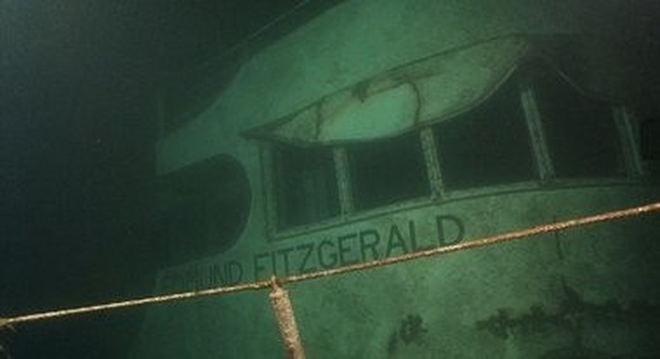
The S.S. Edmund Fitzgerald sank during the early mornings of November 10th 1975. Among the crew, 29 lives were lost - captain, first, second, and third mates, five engineers, three oilers, a cook, a wiper, two maintenance men, three watchmen, three deckhands, three wheelsmen, two porters, a cadet, and a steward. Most of the crew were originally from Wisconsin and Ohio. Captain McSorley had been planning to retire after the S.S. Edmund Fitzgerald’s season. The area where the ship sunk has proven to be treacherous, as the Whitefish Point area has claimed at least 240 other ships during the last 200 years (Thompson 2000). Recovery efforts began 4 days later as U.S. Navy Lockheed P-3 Orion aircraft located the wreck about 15 miles west of Deadman’s Cove, 17 miles from the entrance to Whitefish Bay, and at a depth of 530 feet. A sonar revealed two large objects close to each other on the lake floor, insinuating that the ship had broken in two. In 1976, the U.S. Navy sent divers down and discovered the bow section of the ship upright in the mud, with a large mass of taconite pellets scattered in the wreckage. Many dive efforts followed to learn more about the night that she sank. The Michigan Sea Grant Program spent three days surveying the S.S. Edmund Fitzgerald in 1989. Longtime professional diver Fred Shannon, privately funded a dive to the wreck taking forty plus hours of video footage. During this dive, Shannon’s group discovered the remains of a crew member still wearing a life jacket at the lake bottom near the ship. This proved the crew members knew they were in trouble as they took precautions to put life jackets on. The S.S. Edmund Fitzgerald was valued at around $24 million, making it the greatest financial loss in history of Great Lakes sailing.
The cause of the ship’s sinking is still fully unknown. Some experts speculate that the hatch covers had been cheaply repaired to save money. Some experts say that the hatch removing and covering process was rushed as Captain McSorley was a captain who prided himself on delivering the ship’s cargo in great time and as cheaply as possible. A Great Lakes captain commented after the sinking that “Every captain knew it was his job to deliver cargo as cheaply and as quickly as possible. And if you didn’t measure up, the company would replace you with a captain who would” (Schumacher 2005). Other experts predict that a high wave swamped the ship, causing it to break apart. Others believe the ship bottomed out after taking in water which was absorbed by the iron pellets.
Gordon Lightfoot’s song, The Wreck of The Edmund Fitzgerald, highlighted that “Superior never gives up her dead.” This was an accurate statement due to Lake Superior’s waters being so cold that they inhibited bacteria growth. Without bacteria growth, the bodies did not resurface. The wreck site is considered a gravesite, as all 29 bodies are still there. The families of victims were extremely upset that their loved ones had been filmed at their gravesite, and lawsuits followed. Shannon wanted to distribute a video that showed a preserved body at the wreck site. Outrage ensued, after many believed it was disrespectful and done for publicity. The victim’s families did not want tabloids getting their hands on the footage. Eventually, a legislative ban on photography of corpses in Michigan bottomlands was enacted. Family members were also pressuring the Canadian government to create a ban on expeditions to wrecks.
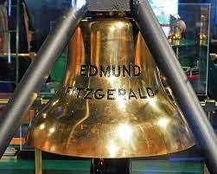
A few months later in 1995, the S.S. Edmund Fitzgerald’s bell was recovered from the ship and blessed by family members. The bell was restored and replaced with a new bell that read the names of all 29 men, acting as a tombstone. The original bell can be seen on display at the Great Lakes Shipwreck Museum in Whitefish Point near Paradise, Michigan. The wreck of the S.S. Edmund Fitzgerald was a huge tragedy that left a solemn feeling across the nation. Gordon Lightfoot wrote his song in memoriam of the 29 lives lost, and the mighty vessel that once sailed the Great Lakes.

Sources:

Bishop, Hugh (2000). The Night the Fitz Went Down. Duluth, Minnesota: Lake Superior Port

Brush, Mark (2015) Listen to radio transmission on the night of the Edmund Fitzgerald's sinking

Captain Dudley Paquette of S.S. Wilfred Sykes, near the S.S. Edmund Fitzgerald during the storm Remembering the Edmund Fitzgerald by Michigan Radio

Detroit Historical https://detroithistorical.org/learn/encyclopedia-of-detroit/s-s-edmund-fitzgerald

Diver Recalls record scuba descent to Edmund Fitzgerald Shipwreck https://www.mlive.com/news/2015/11/terrence_tysall_edmund_fitzger.html

MacInnis, Joseph (1998). Fitzgerald's Storm: The Wreck of the Edmund Fitzgerald. Charlotte, North Carolina: Baker and Taylor for Thunder Bay Press

National Transportation Safety Board (May 4, 1978). "Marine Accident Report: SS Edmund Fitzgerald Sinking in Lake Superior on November 10, 1975" (PDF).

https://ssedmundfitzgerald.org/fitz-timeline
Schumacher, Michael. Mighty Fitz: the Sinking of the Edmund Fitzgerald. University of Minnesota Press, 2012.
Thompson (2000). Graveyard of the Lakes. Detroit: Wayne State University Press.

Thompson (1994). Queen of the Lakes. Detroit: Wayne State University Press. ISBN 0-8143-2393-6.

Vinland Skip (2010) Mariners Weather Log Vol. 54 No. 3 https://vos.noaa.gov/MWL/dec_10/shipwreck.shtml

Picture sources:

https://www.mlive.com/news/2015/11/terrence_tysall_edmund_fitzger.html - Edmund Fitzgerald on lake bottom

https://ssedmundfitzgerald.org/bell-restoration - Bell in museum

https://www.cleveland.com/news/2019/10/wreck-of-the-edmund-fitzgerald-national-museum-of-the-great-lakes-offers-schoonmaker-freighter-tour-to-make-sense-of-mystery.html - at sea

https://www.thegazette.com/history/time-machine-edmund-fitzgerald-the-ill-fated-ship-bore-name-of-insurance-company-president/#:~:text=Home%20%2F%20News%20%2F%20History-,TIME%20MACHINE%3A%20Edmund%20Fitzgerald%20%E2%80%94%20the%20ill%2Dfated%20ship%20bore,name%20of%20insurance%20company%20president&text=Edmund%20Fitzgerald%2C%20president%20of%20the,in%201958%20and%20sank%20Nov. - Mr. Edmund Fitzgerald

